Department of Computer Science and Engineering

CSE-1004 Fundamentals of Electrical and Electronics Engineering
Title of Experiment
Verification of superposition theorem

Name of the Student | Rajyavardhan Singh Bais
Registration Number | 26U020032
Due Date of Submission: 29/09/2026 |  | Date of Submission: 29/09/2026

Assessment Rubrics
Description | Mark Allotted | Mark Secured
Apparatus required and Important definitions | 10
Experimentation: Connection, Conduction and Verification | 35
Theoretical Calculations | 25
Results and Inference | 10
Viva questions | 20
Late Submission/Plagiarism Mark Deduction | 10
Total Marks | 100

Signature of Lab in-charge

Activity Sheet
Verification of superposition theorem

0. Experiment Background
Electric network theorems are a set of principles used in electrical engineering to simplify and analyze electrical circuits. These theorems are fundamental for understanding how different components within a circuit interact with each other and how they affect the overall circuit behavior. Network theorems have a wide range of applications in electrical engineering, helping to simplify the analysis and design of electrical circuits. Some key applications are Simplification of Complex Circuits, Circuit Design and Optimization, Fault Analysis, Transient Analysis and Troubleshooting and Testing. The superposition theorem is a circuit analysis theorem used to solve the network where two or more sources are present and connected. The superposition theorem is very important in circuit analysis because it converts a complex circuit into a Norton or Thevenin equivalent circuit.

1. Lab Activity
Find the current flowing through 20 Ω using the superposition theorem.
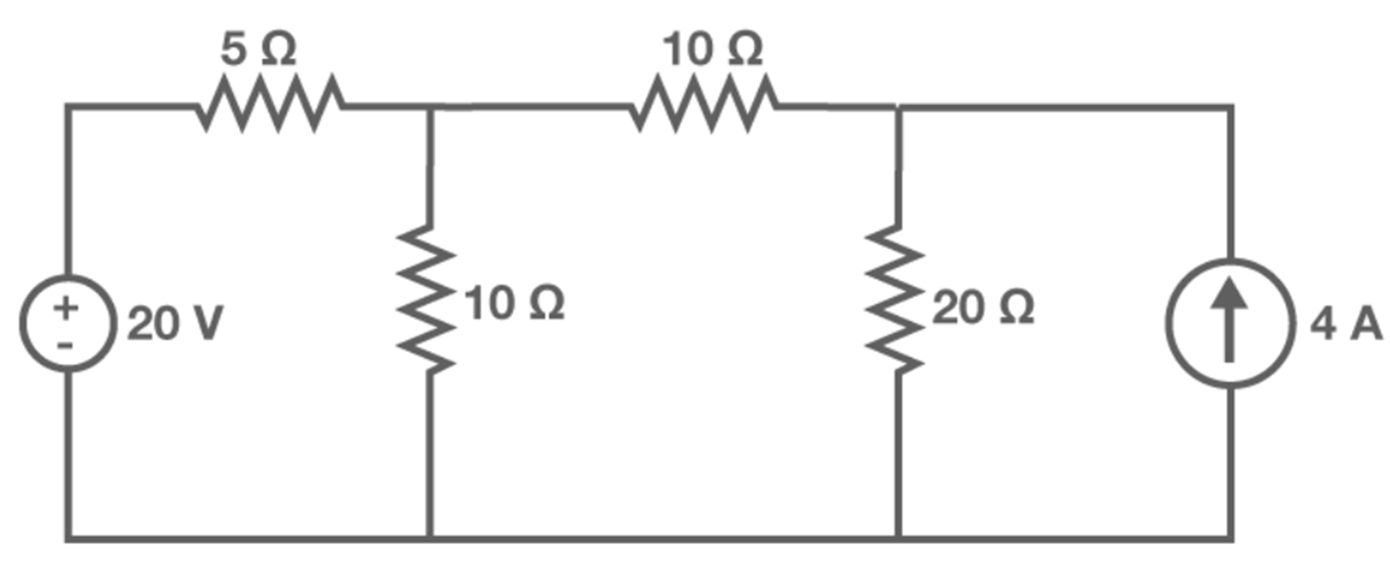

2. Apparatus Required
Based on the given circuit, list the various apparatus required with specifications to conduct the experiment.

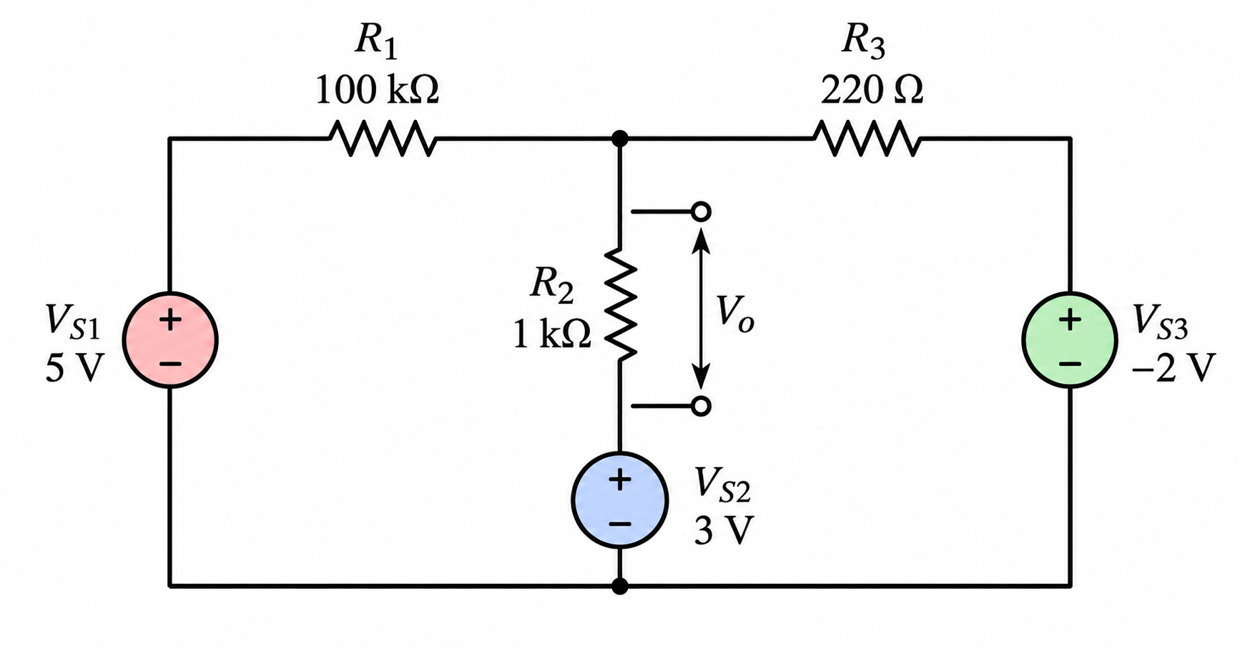

S.No | Name of the apparatus | Type | Range | Quantity
1 | DC Regulated Power Supply | DC | 0-15V | 3
2 | Resistors | Fixed | As per the resistance | 3
3 | Multimeter | - | mA range  V range | 1
4 | Bread board | - | - | 1
5 | Connecting wires | Jumper wires | - | 2-4

3. Important Definitions
Before the experiment, define the following technical terms relevant to the experiment.
Ideal and practical voltage source | Ideal voltage source: A voltage source that maintains a constant terminal voltage regardless of the current drawn from it. Its internal resistance is zero.  Practical voltage source: A voltage source having a small internal resistance, due to which its terminal voltage changes with the current drawn from the source.
Ideal and practical current source | Ideal current source: A source that supplies constant current regardless of the voltage across its terminals. Its internal resistance is infinite.  Practical current source: A current source having a large but finite internal resistance, so the supplied current varies slightly with terminal voltage.
Superposition theorem | In any linear electrical network containing multiple independent sources, the current or voltage in any element is equal to the algebraic sum of the currents or voltages produced by each independent source acting individually, with all other independent voltage sources replaced by short circuits and independent current sources replaced by open circuits.

4. Equivalent Circuit Diagram: Superposition Circuit’s to find the current

Superposition circuit’s | Superposition circuits are the equivalent circuits obtained by considering the effect of one independent source at a time, while replacing all other independent voltage sources by short circuits and independent current sources by open circuits.

- Experimentation: Connection, Conduction and Verification

(1) Connect the components as shown in the circuit diagram.
(2) Switch on the DC power supplies V_{S1} & V_{S2} (e.g.: to 10 V & 5 V) and note down
the corresponding ammeter reading. Let this current be I.
(3) Replace the power supply V_{S2} (5 V) by its internal resistance and then switch on
the supply V_{S1} (10 V) and note down the corresponding ammeter reading. Let this current be I₁.
(4) Now connect back the power supply V_{S2} (5 V) and replace the supply V_{S1}(10 V)
by its internal resistance.
(5) Switch on the supply V_{S2} (5 V) and note down the corresponding ammeter reading.
Let this current be I₂.
(6) Repeat the steps 2 to 5 for different values of V_{S1} & V_{S2}.
(7) Verify the theorem using the relation I = I₁ + I₂ (for T- Network) & I = I₁ ~I₂ (for
Symmetrical π- Network)

Table-1: Verification of superposition theorem
Measurement of current
Experimental | Supply voltage (V)
Experimental | Current (A)
Theoretical | Supply voltage (V)
Theoretical | Current (A)

- Theoretical Calculations

Find the appropriate conditions and write down the suitable formulas.

Question | Conditions to find | Select & write the correct condition
In the superposition theorem, when we consider the effect of one voltage source, all the other voltage sources are | - Shorted  - Opened  - Removed  - Undistributed | - Shorted
The superposition theorem is valid for | - Linear systems  - Non-linear systems  - Both linear and non-linear systems  - Neither linear nor non-linear systems | (a) Linear systems​
The superposition theorem does not work for | - Current  - Voltage  - Power  - Works for all: current, voltage and power | (c) Power
A superposition theorem deals with ____ type of supplies connected in an electrical circuit? | - Independent  - Dependent  - Linear  - Both b and c | (a) Independent

7. Results & Inference
The Superposition Theorem was studied and verified theoretically for the given linear electrical network containing three independent voltage sources. The response across R2R_2 due to all the sources acting simultaneously was compared with the algebraic sum of the individual responses obtained by considering each source separately. The theoretical results were found to satisfy the relation Vo=Vo1+Vo2+Vo3Any difference between theoretical and experimental values may be attributed to resistor tolerances, power-supply variations, meter accuracy, connection resistance and measurement errors.

- Viva Questions

- How does the Superposition Theorem apply to the analysis of communication systems?

Superposition is useful in linear communication circuits where signals from multiple sources are present. The individual contribution of each signal can be analyzed separately and then combined to determine the total response.

- Explain the use of the Superposition Theorem in optimizing the performance of a power distribution network in commercial buildings.

A distribution network may contain multiple sources and loads. Superposition allows the effect of individual sources to be analyzed separately, making it easier to study voltage and current contributions at different parts of the network.

- Describe how the Superposition Theorem is utilized in the analysis of fault conditions in an industrial power supply network.
In a linear network, individual sources can be considered separately to determine their contributions to currents and voltages during a fault condition. This helps analyze the effect of different sources on the fault response.

- How can the Superposition Theorem be applied in the analysis of lighting systems in large sports stadiums, where multiple power sources are used?

For a linearized electrical model, each independent supply can be considered separately to determine its contribution to voltages and currents in the lighting network. The individual responses can then be algebraically combined to obtain the total response.

